Gymnastics for All
East Midlands Regional
Competition Handbook

Competition Organisers’ name: East Midlands GfA Committee

About
East Midland Gymnastics Association
Our aim is to provide gymnastics opportunities for all ages and abilities across the East Midlands.

The region is made up of 5 counties starting in the North with Derbyshire, then into Nottinghamshire across to Lincolnshire, then down to Leicestershire, and finally finishing with Northamptonshire in the South.

The EMGA accounts for one of the 10 regions that form the English Gymnastics Association that in turn is the regional arm of British Gymnastics. We work as one organisation to provide opportunity and development for our sport both regionally, nationally and internationally.

To help the region function we have a regional exec team consisting of a Chair, a Treasurer, Secretary and Regional Welfare officer. In conjunctions with the exec there is the BG development team consisting of an Area Manager and several representatives to support clubs. The development team actively work with the regions clubs to ensure we can help our clubs and disciplines meet the demand of our customers, now and in the future.
British Gymnastics
British Gymnastics is proud to be the UK Governing Body for the sport of Gymnastics. We exist to support, lead and inspire all those involved or interested in Gymnastics.
British Gymnastics provides a national directive and structure for the sport; delivering a range of opportunities across the age spectrum to take part and stay in gymnastics, as well as developing talent and delivering top-level success.
The British Gymnastics strategy aims to meet the following vision and core purpose:
- Gymnastics is a passion shared by millions.
- To create and inspire lasting success for Gymnastics.
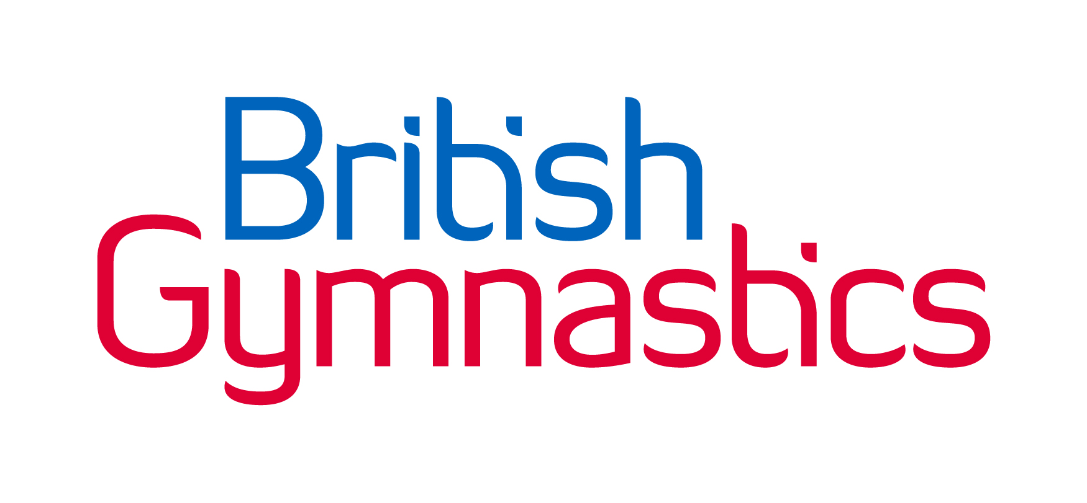
Table of Contents
About 1
Competition details – Overview 4
Who can enter? 4
Dates, Competition, Level, Venue, Address 5
Theme 6
Entry costs overview – Clubs, Gymnasts, and Spectators 6
Entry method and closure date 7
Payment method 7
Key contacts 8
Entry details 9
Late entries 9
Changing of a gymnast involved in the competition 9
Withdrawal of entry 9
Confirmation of entry 10
Structure and programme 10
Type, level, and pathway 10
Confirmation of programme 11
Pre-planned structure of competition 11
Category breakdown 11
Gymnasts that have… 13
Maximum training hours 14
Adaptations: Disability or Mainstream category? 14
Disability Gymnasts: Classification of impairment 15
Rewards and gifts 15
Performance details 16
Warm up 16
Music licencing – PPL/PRS 16
Lining up 18
Skill requirements and Tariff sheets 18
All apparatus – Repetition of skills 18
Floor – Missing elements 18
Floor – Restarting 18
Apparatus 18
Deductions 20
Judge slip example 20
Appealing a judge’s decision 21
Club, school, and leisure centre requirements 21
Judge, Coach, Gymnast requirements 21
Volunteers 25
Facilities on-site 25
Spectator area and disabled access 25
Food and drink 25
Toilet and changing facilities 25
On-site entertainment 25
Car parking 25
First aid and welfare 25
Regulations 26
Standardisation 26
Etiquette 26
Photography 26
Complaints and grievances 27
Health and safety 28
Allergies 29
Emergencies 29
Terms and conditions 30

Competition details – Overview
Welcome to the East Midlands Gymnastics Competition Handbook, within this pack you will find all the details to participate within our competitions, support by British Gymnastics.
The aim of this gymnastics competition is to provide an opportunity for gymnasts to participate within a recreational and fun competitive environment. This competition breaks down the ‘Key Skills’ involved in General Gymnastics (also the other disciplines) and builds them up towards more challenging skills which gymnasts love to do in any environment.
This competition is a Regional level focused competition aimed at those who otherwise would have few competition opportunities.

Who can enter?
This competition is for:
Gender | Boys and Girls (see specific event)
Age | 5 years +  Gymnasts must be of age [to enter the appropriate category] in the year of the competition.  For example: A gymnast must be turning the age that year with the exception of the 5 years category, gymnasts must be age 5+ on the day of the competition to be able to compete
Ability | These competitions are aimed at individual gymnasts training a maximum of 1 – 6 hours per week (category dependant) within a General Gymnastics setting.
Club, County, Region | This is open to all British Gymnastics clubs who are affiliated to East Midlands Gymnastics Association (EMGA).  Anyone within the East Midlands region can be affiliated. For further details see ‘Club requirements’ section.
See ‘Category breakdown’ and ‘Entry restrictions: Gymnasts that have...’ for specific details.

Dates, Competition, Level, Venue, Address
2022 competition dates | Competition | Level | Venue, Post code
22 May 2022 | 3 Piece Festival Under 8’s Years | 8s and under | Amber Valley Gymnastics Club  Unit 2 Asher Lane, Pentrich,  Ripley,  Derbyshire,  DE5 3SW
12th June 2022 | 4 Piece Primary 2 and Primary 1 | Primary 2  (all ages)  Primary 1  (all ages) | Amber Valley Gymnastics Club  Unit 2 Asher Lane, Pentrich,  Ripley,  Derbyshire,  DE5 3SW
26th June 2022 | 4 Piece Adv, Adv+, Adv+ Challenge | Advanced  (all ages)  Advanced Plus  (all ages)  Advanced Plus Challenge  (all ages) | Amber Valley Gymnastics Club  Unit 2 Asher Lane, Pentrich,  Ripley,  Derbyshire,  DE5 3SW
16th October 2022 | Floor and vault Festival 8s and unders | 8 and under | Erewash Valley Gymnastics Club  Hallam Fields Road, Ilkeston,  DE7 4AZ
6th November 2022 | Floor and Vault Primary 2 and 1 | Primary 2 – Girls  Primary 1 – Girls | Erewash Valley Gymnastics Club  Hallam Fields Road, Ilkeston,  DE7 4AZ
13th November 2022 | Floor and Vault  Adv, Adv+, Adv+ Challenge | Advanced  (all ages)  Advanced Plus  (all ages) | Erewash Valley Gymnastics Club  Hallam Fields Road, Ilkeston,  DE7 4AZ
Start time: All competition start times are estimated to be approximately 8:30am.
Estimated end time: All competition end times are estimated to be approximately 4:00pm
Note: The start and end times are estimated and subject to change pending entries received and category breakdown. Maximising your experience is vital, please be patient with the Competition Organiser.
Programme circulation: The Competition Organiser will aim to circulate the programme within 10 days of the event date, if not earlier.
Please note: These are just Regional competitions being hosted by EMGA, please see Find an Event on the British Gymnastics website for further competitions at various levels.

Theme
This event has the following theme: | There is no theme for any of these events.

Entry costs overview – Clubs, Gymnasts, and Spectators
Cost per competing gymnast: | ££12.50 floor and vault £15.00 for 3 piece festival or 4 piece
Cost per competing  gymnast in teamed event: | N/a – No teamed events

Also required as part of entry: | Volunteers | Display group or individual to perform between rounds
 | One | N/a

Cost per spectator: | Adult | Concession and Child (under 14 years) | Infant (under 2 years)
 | £5.00 | £0.00 | £0.00
 | Spectator fees are paid on the day of the event, on arrival to the venue.
Please be aware, there is limited seating. Please speak with the Competition Organiser if you have a large group of spectators attending.
Cost for no allocated judge (per gymnast): | No judge = No entry
Cost for no show judge (per judge): | £75.00
Note: See Judge Requirements section for specific requirements
Any gymnasts, coaches, spectators, or judges requiring additional requirements please state on the entry form.

Entry method and closure date
Entry method: | British Gymnastics online entry system (GymNet) – see specific event for entry system link
Entry opening date: | Estimated 2 calendar months prior to event date (see Find an Event for specifics)
Entry closure date: | Estimated 1 calendar months prior to event date (see Find an Event for specifics)
Notes:
- The Competition Organiser holds the right to close the entry period early if the maximum entries have been reached.
- Disability entries to enter via their chosen category, then selecting the disability option upon entry where then stating in detail their disability and specific needs

Payment method
As part of the British Gymnastics online entry system (GymNet), you will be able to pay for your entries.
Please ensure the correct amount is paid upon entry. Without payment, entry will not be submitted or counted.
Upon entry please state when you will expect payment will be received by the hosting club, as this can affect organisation planning, and would be greatly appreciated.

Key contacts
Chair | Susannah Watts | eastmidsgfa@gmail.com | N/a
Deputy Chair | Alex Shaw | eastmidsgfa@gmail.com | N/a
Committee member | Jo Robb | eastmidsgfa@gmail.com | N/a
Committee member | Jo Shaw | eastmidsgfa@gmail.com | N/a
Committee member | Danielle Humenko | eastmidsgfa@gmail.com | N/a
Competition Welfare Officer | Caroline Lee | TBC | 07935831957
East Mids GfA Facebook page | https://www.facebook.com/groups/458370661411294/
British Gymnastics Competition Coordinator: | Jack Duggan | 07584517635 | jack.duggan@british-gymnastics.org
 | Karen Coleman | 07584515030 | karen.coleman@british-gymnastics.org
 | Polly Hucker | 07584515030 | polly.hucker@british-gymnastics.org
Keeping in ‘the loop’
- For general updates to this event – Register your interest within the Competition Organiser
- For ongoing event updates –
  - Log into your Membership on the British Gymnastics and amend your ‘Preference’ within the GymNet section.
  - Follow the various Facebook pages (click image for direct link to page):

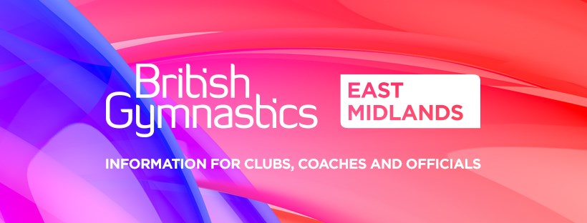

Entry details
Please see the following sections for initial details regarding entries:
- Entry costs overview - Clubs, Gymnasts, and Spectators
- Entry method and closure date
- Payment method

Late entries
Entries received after the entry closure date may incur the following administration charge:
Late entry fee: | £18.00 per gymnast
If you believe your entry will be late, please contact the Competition Organiser to discuss your situation. Each case is taken on individual basis.

Changing of a gymnast involved in the competition
Pre-event entry closure
If a gymnast is unable to attend the event for a specific reason (injury, illness etc.) then you are welcome to transfer (change) the gymnast so you maximise the opportunity for your club.
- Not submitted your entry yet? – You can manually amend your entry list on GymNet
- Submitted (paid) for your entry? – You will need to email the Competition Organiser to request a transfer in gymnast, as this must be done manually.
Post event entry closure
Contact the Competition Organiser to discuss your individual situation and the stage of event organisation. It may be too late to alter/re-do any preparation that has been completed for the big day.
If a transfer is accepted and must be done manually, the Competition Organiser will need the following details of both the old and new gymnasts:
- Full name
- Membership number
- Category – Level and Age

Withdrawal of entry
To withdraw a gymnast please email the Competition Organiser with the following details:
- Full name
- Membership number
- Category – Level and Age
- Reason for withdrawal
Fees to withdraw
If the withdrawal is:
- After the closure date – Full cost of the entry fee.
- Before submission of the entry – No fee has been charged.
- Before the closure date – No fee will be charged as part of consumer rights.

Confirmation of entry
Upon entry and payment of entry; you will receive a confirmation email for your entry.

Structure and programme

Type, level, and pathway
Competition type: Gymnastics for All
Competition level: Primary 2 to GfA Adults
Competition pathway:
The following diagram provides a simple visual of the Gymnastics for All pathway at East Midlands Regional level for boys and girls.
Each discipline will have specific pathway requirements; please see the British Gymnastics Technical pages for further details.
East Midlands Gymnastics Association accept Disability Gymnasts into their competitions. EMGA encourage Disability Gymnasts into their events by adapting their main events where possible and using additional categories where appropriate.
See the Gymnasts that have... section of this document for details regarding any specific entry levels restrictions e.g. gymnasts that have entered Artistic competitions prior to this competition.
If you have developed your gymnasts to a higher standard (which is great) then exploring other discipline competitive pathways maybe an option – Please see the East Midlands Gymnastics Association – Contact Us web page for discipline representative contact details.

Confirmation of programme
After the entry closure date, the Competition Organiser will finalise the competition programme/running order and circulate this with all clubs involved.
If you haven’t received an email of the competition programme five days prior to the competition start date, please contact the Competition Organiser.
Note: Sometimes emails can get moved to ‘junk mail’ boxes without our knowledge, please check prior to contacting the Competition Organiser.

Pre-planned structure of competition
Below is a guide of the structure of the competition, this will be adapted and confirmed after the closure date.
Note: Some competitions may be broken up into separate smaller competitions to suit the number of entries/categories, for example a morning and afternoon competition using the same templated programme.
Activity | Estimated time
Arrival | 8:30am
Registration | 8:30am
Door open for spectators | 8:30am
Coaches and judge’s briefings | 8:45am
Judges briefing | 8:45am
General warm up | 8:45am
Competition begins | 9:00am
Rounds including change over, intervals, apparatus warmups, performances
Presentation | 11:40am
Photo opportunity | 11:40am
Competition ends | 12:00noon

Category breakdown
Within these competitions the categories are as follows:
Competition | Categories | Ages
Floor and Vault  Under 8 Years | Under 8’s – Boys  Under 8’s – Girls | 5 Years  6 Years | 7 Years  8 Years
Floor and Vault Primary 2 and Primary 1 | Primary 2  Primary 1 | 8 years  9 Years  10 Years  11 Years  12 Years | 13 Years  14 Years  15 Years  16 Years
Floor and Vault  Adv, Adv+, Adv+ Challenge | Advanced  Advanced Plus  Advanced Plus Challenge | 10 Years  11 Years  12 Years  13 Years | 14 Years  15 Years  16 Years
Four Piece Primary 2 and 1 | Primary 2  Primary 1 | 8 years  9 Years  10 Years  11 Years  12 Years | 13 Years  14 Years  15 Years  16 Years
Four Piece Adv, Adv+, Adv+ Challenge | Advanced  Advanced Plus  Advanced Plus Challenge
Open to all Disability Gymnasts.
Depending on the number of, ages, and requests of adaptations post entry closure will determine the number of and type of categories.
Contact the Competition Organiser to discuss options at this recreational event.

Also see ‘Adaptations: Disability or Mainstream category?’ section for further information.
All (unless stated) | All (unless stated) | All (unless stated)
See specific competition | See specific competition | See specific competition
Notes:
- Depending on the number of entries in each category after the closing date, some categories are subject to change.
For example; 7 years may become two groups of 7 years, Jan – Jun born and Jul – Dec born. This may also work in reverse, for example; 8 and 9 years will join as there are only 2 in each age group entered.
This will be down to the discretion of the Competition Organiser, but this will be communicated prior to the competition date.
- Gymnasts must be of age [to enter the appropriate category] in the year of the competition.
For example: All categories will be split by what year the gymnast is born in
- In fairness to all gymnasts, the coach should decide at what level gymnasts compete.
  - 8-year-old gymnasts can enter either the Under 8 Years competition or the Primary (and above) competitions. This is to allow a smoother transition during ability changes. The coach and gymnast are to decide this ethically.
- Gymnasts are to compete in the same level on all apparatus.
- Gymnastics for All (GfA) rules are designed to be inclusive:
  - Gymnasts with additional needs may take part within a mainstream category or a disability specific category.
  - If any gymnasts have specific additional needs/support, please make the Competition Organiser aware upon entry.

Gymnasts that have…
- Entered Artistic Floor and Vault competitions not eligible to enter Regional GFA competitions
- Entered Gymnastics for All Floor and Vault competitions and won a medal must move up a level in the following year
- Entered Gymnastics for All Four Piece competitions and won a medal must move up a level in the following year
- Entered Artistic County or Regional Four Piece Competitions zinc or above or Regional/National Grades and / or Tumbling National 1 at or higher are not eligible to enter Regional GFA competitions
- Competed at Club Grade 6 and 5 can enter as long as they are only doing the hours of training limit.
- Been a former Artistic Gymnasts wishing to compete at a lower level may do so, but must not have competed for one year, and enter at the Advance Levels
Note: With all points, the discretion of the coach’s professional judgement on the level which a gymnast should enter; and they should not advance the gymnast beyond their level or hold the gymnast back for the success of the club.
Apart from the above restrictions, you may enter any gymnasts at any level e.g. a gymnast could enter the Advanced although they have never entered a competition prior. Thus, keeping in mind the physical and psychological factors involved with entering a gymnast at a higher level as their first time.

Maximum training hours
To ensure a fair competition, we have enforced the following maximum training hours per week:
Gender | Primary 2 | Primary 1 | Advanced | Advanced Plus | Advanced Plus Challenge
Girls | Four | Four | Six | Six | Six
Boys | Four | Four | Six
This applies to each individual gymnast and includes all training hours no matter discipline.

Adaptations: Disability or Mainstream category?
When deciding with your gymnasts if they wish to enter a competition, you need to discuss if they wish to enter as into a mainstream category or a disability category.
To support gymnasts, integrate into mainstream gymnastics there can be certain adaptations allowed without effecting how the gymnasts are scored/judged. If you would like to discuss any possible adaptations prior to entering this event, please contact the Competition Organiser whereby you can discuss the most suitable option based on the needs of the individual.
Gymnast will be categorised into impairment groups dependant on the number of entries as you will see in the classification section below.
Entering: Mainstream category
Following the process set in the Entry method and closure date section, completing the ‘Gymnasts details’ tab.
Entering: Disability category
Following the process set in the Entry method and closure date section, completing the ‘Gymnasts details – Disability Gymnasts’ tab.

Disability Gymnasts: Classification of impairment
As part of your entry form you will be asked to select the most appropriate classification(s) for your disability. This will help the Competition Organiser to organise the most appropriate categories for the competition. The Competition Organiser will use a similar process to create the appropriate categories for this event:
 | Are the gymnast’s mainstream or disability? | What level are they | Male or Female? | How old are the gymnasts? | What adaptations are required? | How do the previous info fit into the classification of impairments?
Competition Organisers options | Mainstream  Disability | Primary 2  Primary 1  Advanced  Advanced Plus  Advanced Plus Challenge | Male  Female | 5 years  6 years  7 years  8 years  9 years  10 years  11 years  12 years  13 years  14 years  15 years  16+ Women’s  16+ Men’s | Individual basis | Hearing  Visual  Physical  Learning
Notes:
- Depending on the number of entries in each Classification of Impairment category after the closing date, some categories are subject to change.
This will be down to the discretion of the Competition Organiser, but this will be communicated prior to the competition date.
- If you are unsure of your Classification of Impairment, please contact the British Gymnastics Competition Coordinator for guidance – see Key contacts section.

Rewards and gifts
As part of this competition every gymnast will receive a:
Well done/participation certificate
As part of this competition 6th – 4th place gymnasts’ in each category will receive a:
6th – 4th place certificate
Well done/participation certificate
As part of this competition 3rd – 2nd place gymnasts’ in each category will receive a:
Medal
Well done/participation certificate
As part of this competition 1st place gymnast in each category will receive a:
Trophy
Medal
Well done/participation certificate
As part of this competition the overall winner (all apparatuses totalled together) of each age group will receive a:
Trophy
Medal
Well done/participation certificate
See ‘Category breakdown’ for explanation of categories.

Performance details

Warm up
There isn’t a warmup hall for the gymnasts. The programme will include a general warm up at the start of the competition but also per apparatus.
There will be approximately 5 minutes per apparatus, although this table helps to breakdown individual timings per gymnast (approx.).
Maximum warm up time – Competition/Apparatus
 | Primary 2 | Primary 1 | Advanced | Advanced Plus | Advanced Plus Challenge
Floor | 5mins | 5mins | 5mins | 5mins | 5mins
Vault | 2mins | 2mins | 2mins | 2mins | 2mins
Beam | 45secs | 45secs | 1min | 1min | 1min
A bars | 1 min | 1 min | 1 min | 1 min | 1 min
High bar | 1 min | 1 min | 1 min
P-bars | 1 min | 1 min | 1 min
Attempts/timings subject to change at the Competition Organisers discretion.
Timings subject to change at the competition organisers discretion.

Music licencing – PPL/PRS
Music requirements for this event
Music is required for the following categories of this competition: | - Advanced – Girls; Floor routine  - Advanced Plus – Girls; Floor routine  - Advanced Plus – Challenge; Floor routine
Note: Timings etc. requirements are stipulated on specific ‘Skills and Tariff sheets’.

Pre-event music requirements
Music submission date deadline: | Same date as closing date for individual event
Music submission method: | Online submission via GymNet
Music format: | MP3 / MP4
Music submission must include the:
- Club/team
- Gymnast full name
- Category
Please ensure you are aware of the stipulations placed on the event and all clubs wishing to use music, by PPL.
If you wish to use music in your gymnastics environment, you require a PPL/PRS licence. More information can be found: http://www.ppluk.com/I-Play-Music/Businesses/
To check your music is permitted for use, the PPL UK website lists online all the music that can be used: https://repsearch.ppluk.com/ars/faces/pages/audioSearch.jspx?_afrLoop=12521061282463709&_afrWindowMode=0&_adf.ctrl-state=27kf5b2cs_4
No Walt Disney, Andrew Lloyd Webber or Cirque de Soleil music is permitted.
Event day music requirements
Please ensure you bring a copy of your music on the day. Ideally within the following formats:
- CD-ROM
- USB (for laptop)
- Fully charged portable device e.g. MP3 player/iPhone etc.
Please note that although very-low risk, any damages are your own responsibility and not the host or the Competition Organisers.
The host venue will also be abiding by the PPL/PRS licencing laws. Therefore, their maybe background music being played to help create a calming atmosphere. This will be the competition organiser/venue representatives’ discretion.
British Gymnastics guidance on PPL/PRS
Within the above information there is some guidance/useful links taken from the British Gymnastics website. For full details please go to https://www.british-gymnastics.org/clubs/club-membership/music-licensing-ppl-prs

Lining up
Please ensure that at the following times the gymnasts line up and present to the audience and judges:
- At the start of the competition (as a team)
- Before the performance
- After each individual/team performance
- During the awards ceremony (as an individual/team)

Skill requirements and Tariff sheets
Skills requirements for this competition can be found in the ‘Skills and Tariff sheets’, accompanying this handbook.
These sheets have been designed to be easy to read for each level.
No physical tariff sheets need to be written for any events.

All apparatus – Repetition of skills
Floor – The Skills and Tariff sheets state how many skills are required for each competition type.
Repeated or additional elements (skills) won’t be counted towards the DV score and will receive Execution Deductions if performed.
Vault – Each gymnast is to perform two vaults. The highest scoring element will be recorded.
Both vaults are to be the same elements at all competitions.

Floor – Missing elements
Any routines with missing elements (skills) will receive a 0.5 deduction from the Judge.

Floor – Restarting
Where music has disturbed the gymnast due to a malfunction or incorrect use of, the music can be stopped/faded out and the gymnast come to safe stop. After which they can restart their routine from the beginning.
Although preferred not to for event time management (e.g. the more times it happens the later the event will finish), this is a General Gymnastics competition and the focus is the gymnasts.

Apparatus
The following equipment and apparatus will be used for these competitions:
Apparatus | Specific use for | Manufacturer | Size, dimensions, run up, landing details | Image
Sprung floor  (New College only) | All levels | GymNova | 12m x 12m  See competition specific requirements | 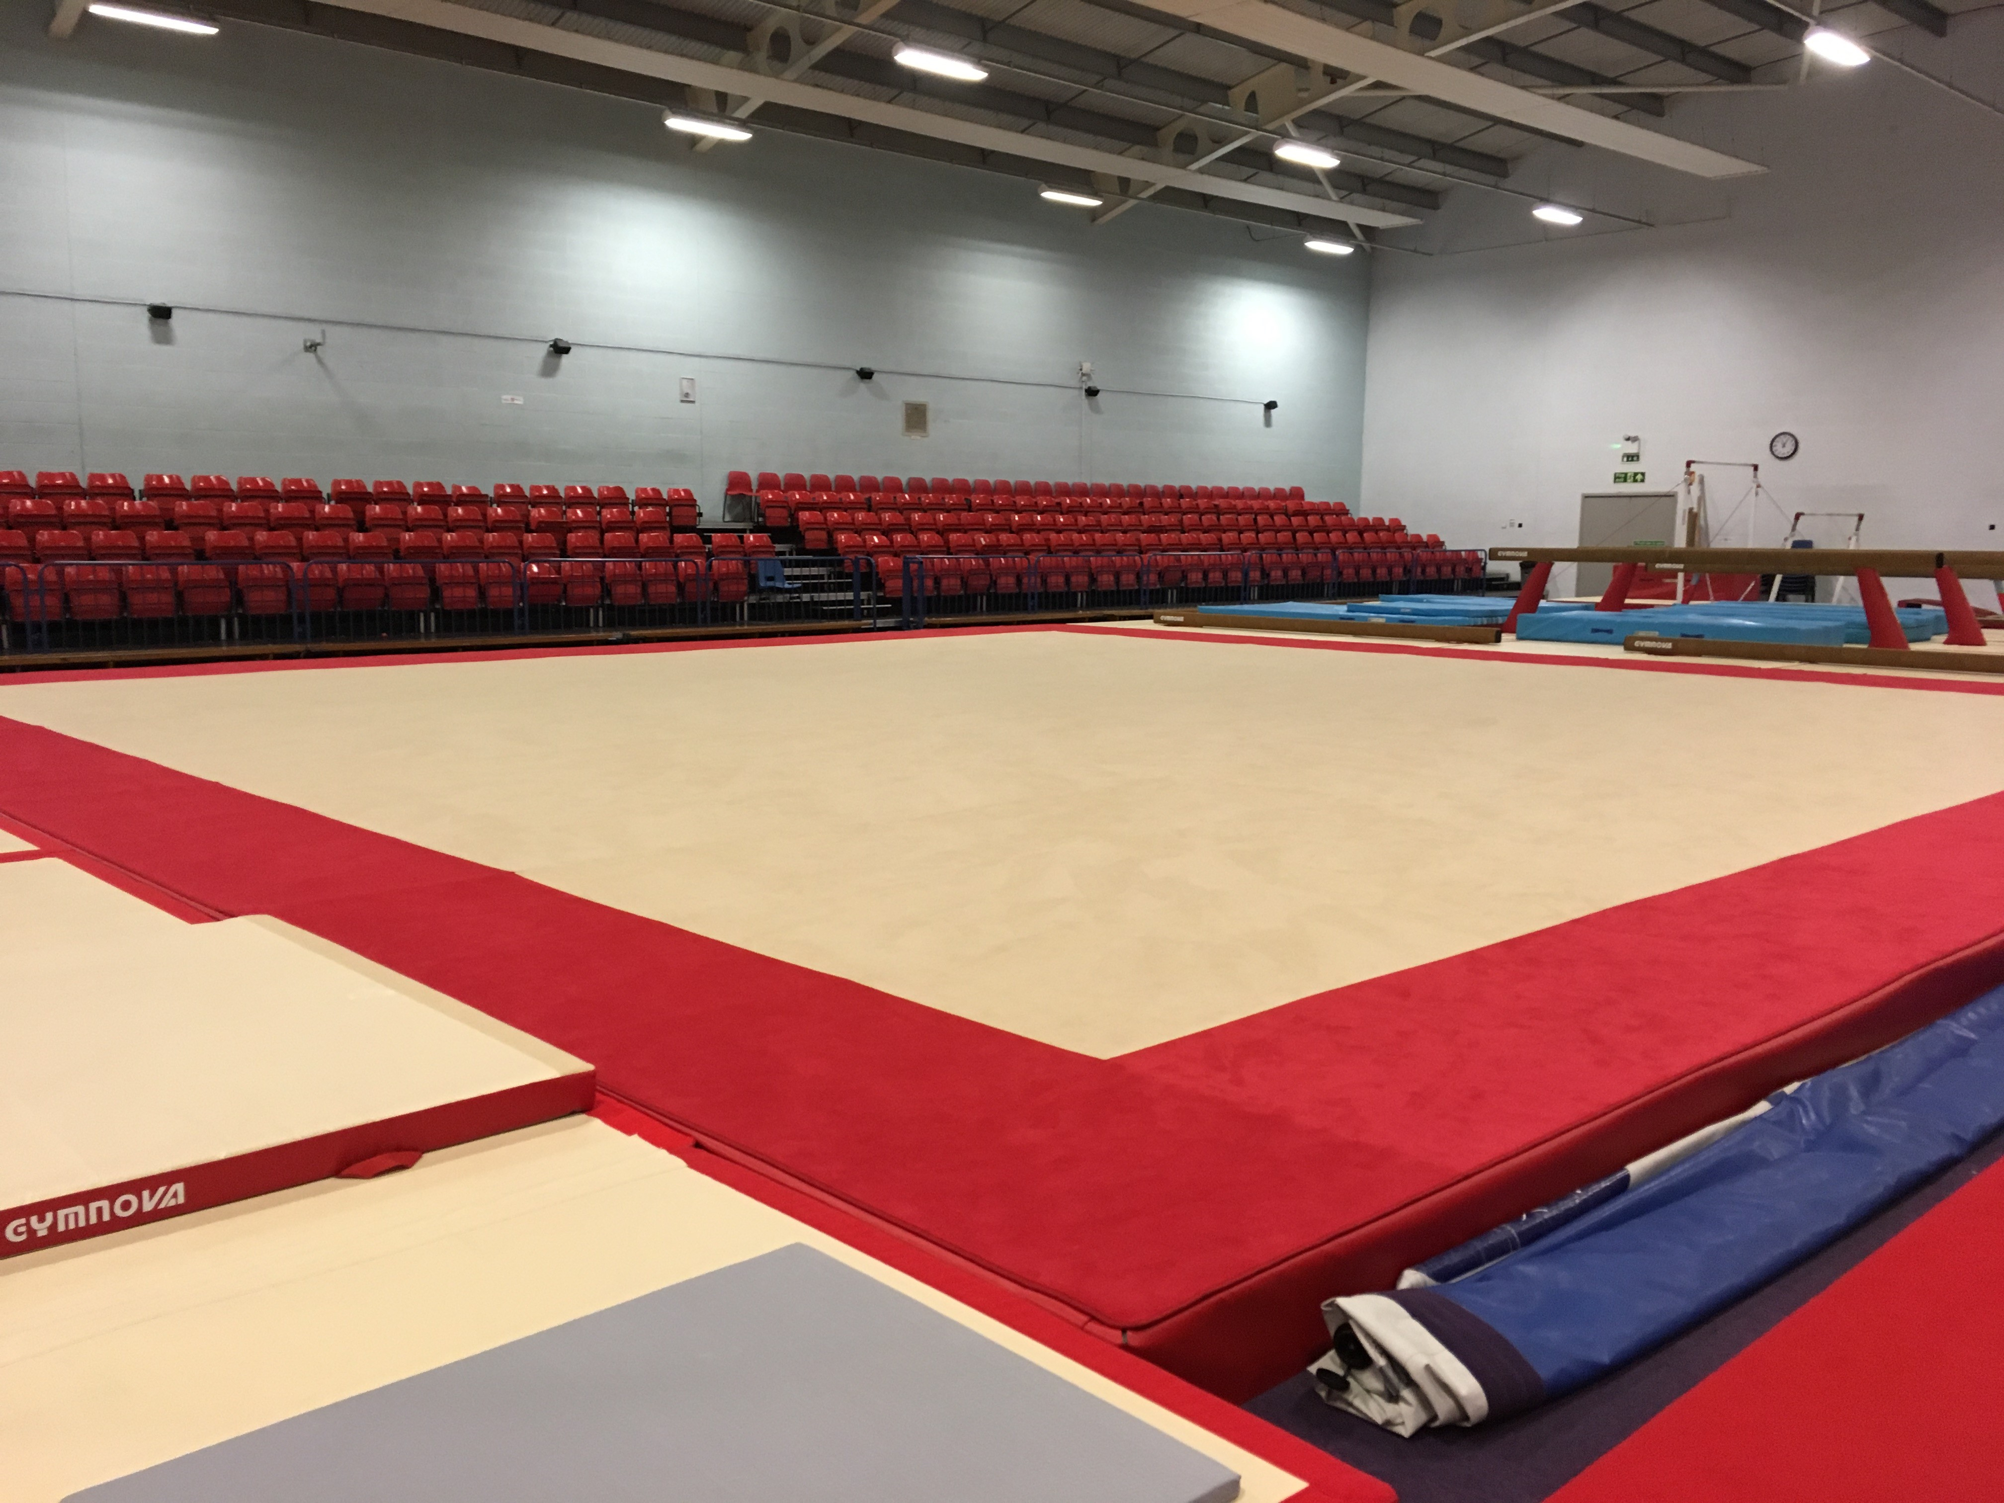
Sprung floor  (Amber Valley only) | All levels | GymNova | 12m x 12m  See competition specific requirements | 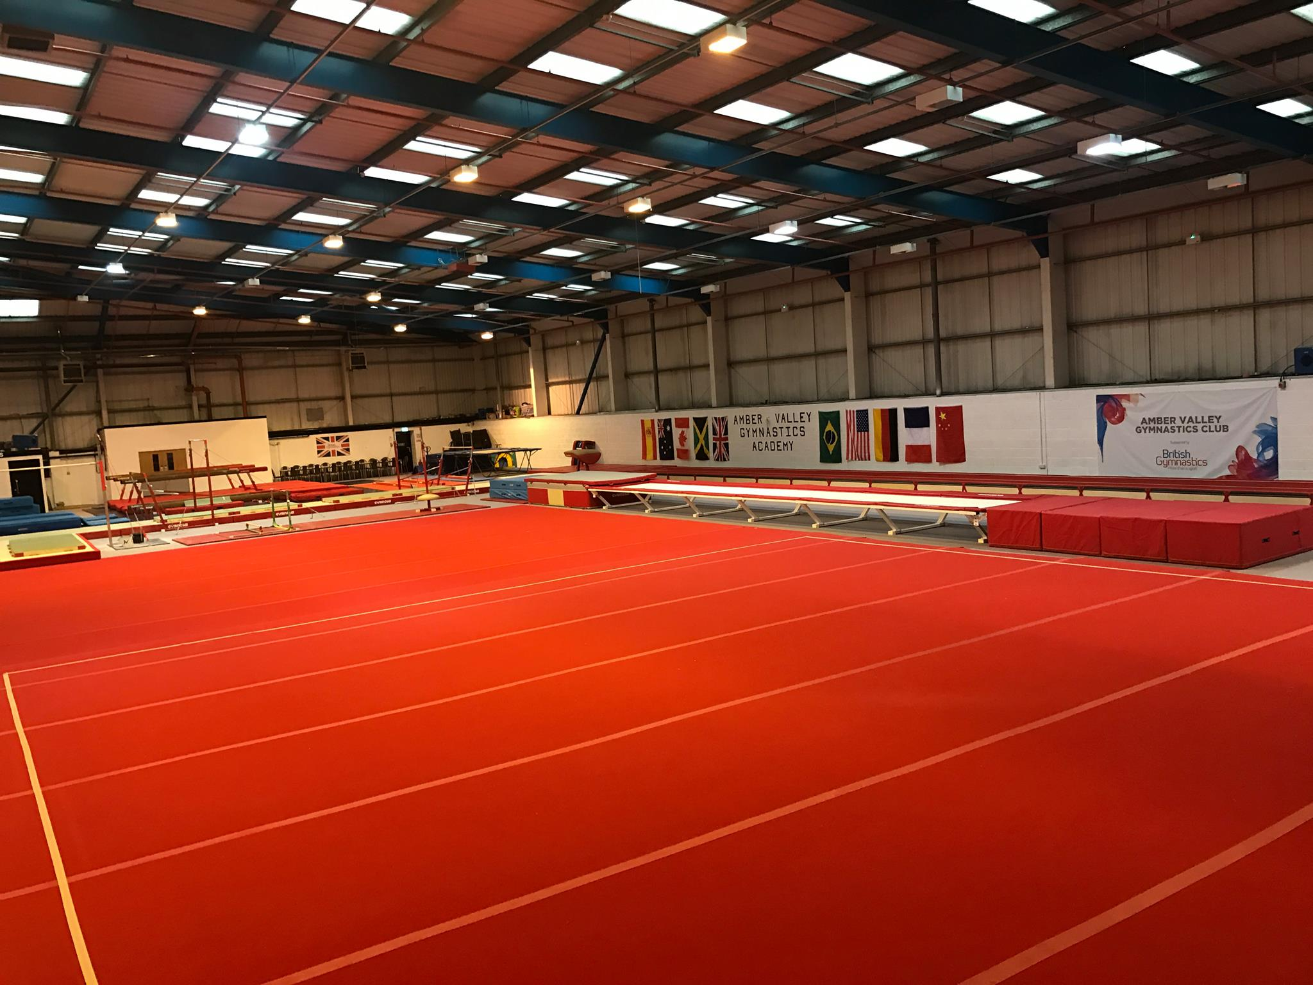
Red block  (Under 8 vault) | Under 8 Years | Generic | Height 100cm | 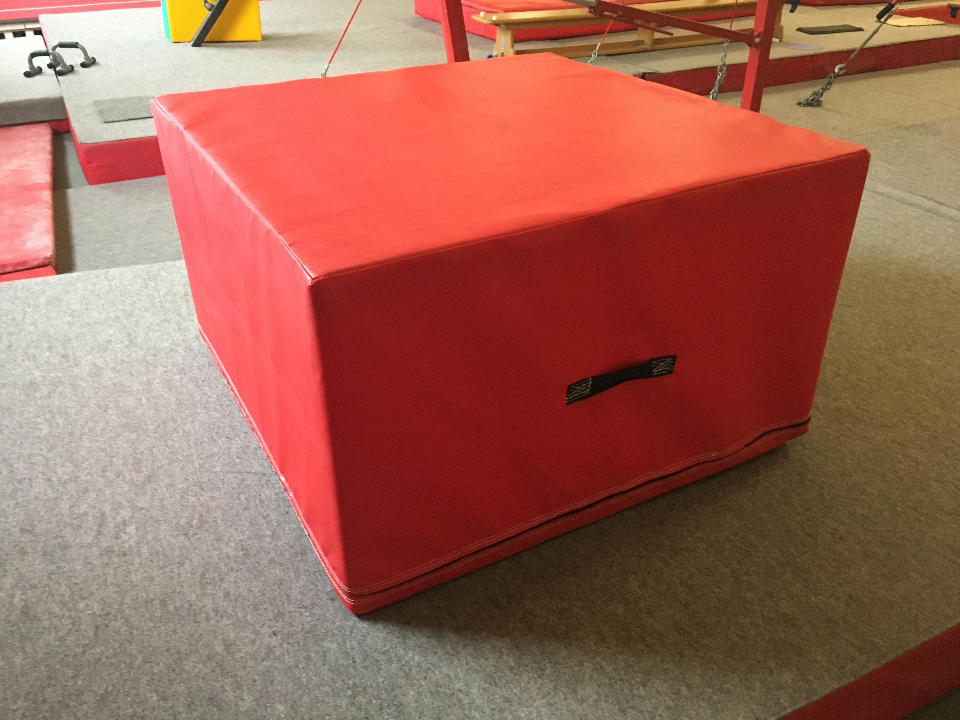
Table vault | Primary 2  Primary 1  Advanced  Advanced Plus  Advanced Plus Challenge | GymNova | Height 100 – 165cm  See competition specific requirements | 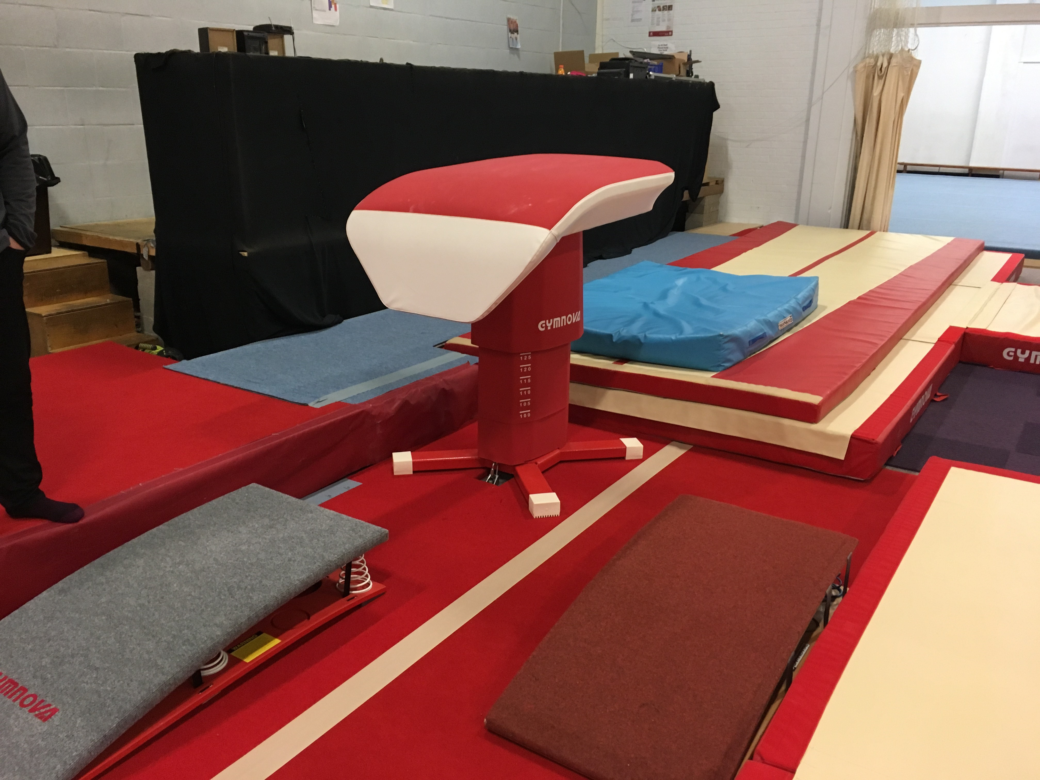
Beam | Girls Four Piece:  Primary 2  Primary 1  Advanced  Advanced Plus  Advanced Plus Challenge | GymNova | As per FIG Apparatus Norms brochure  Length: 500cm  Width: 10cm | 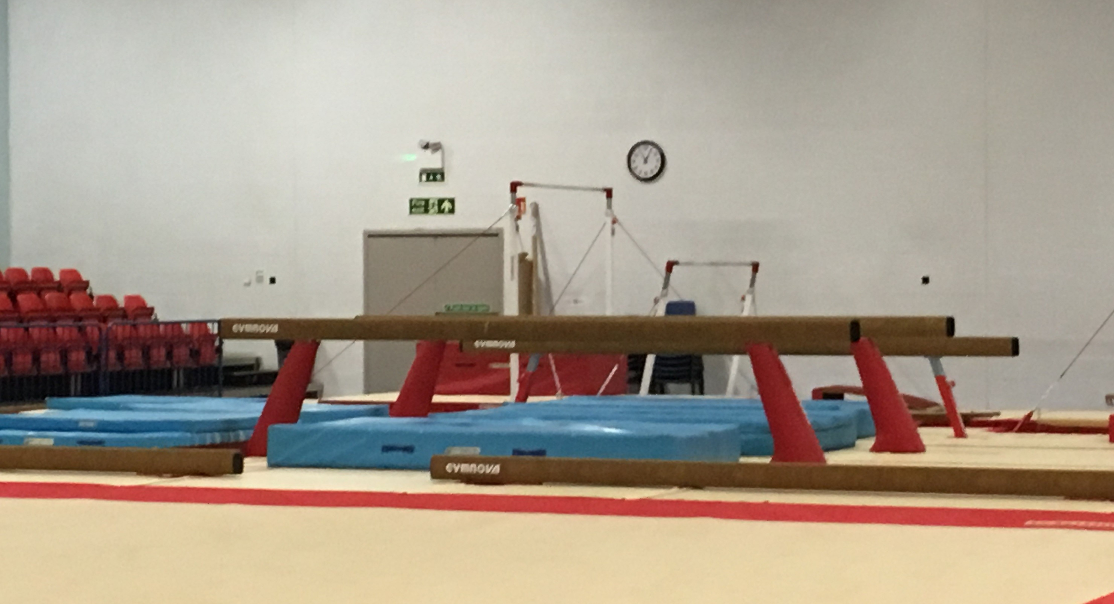
A Bars | Girls Four Piece:  Primary 2  Primary 1  Advanced  Advanced Plus  Advanced Plus Challenge | GymNova | As per FIG Apparatus Norms brochure  Height of bar: adjusted to suit gymnast  Distance between bars: min 130cm – 180cm max
Trampette | Boys Four Piece:  Primary 2  Primary 1  Advanced  Advanced plus | GymNova | With flat run up and a springboard to step up if needed
H Bar | Boys Four Piece:  Primary 2  Primary 1  Advanced  Advanced plus | GymNova | Can be adjusted by coach to suit the gymnast | 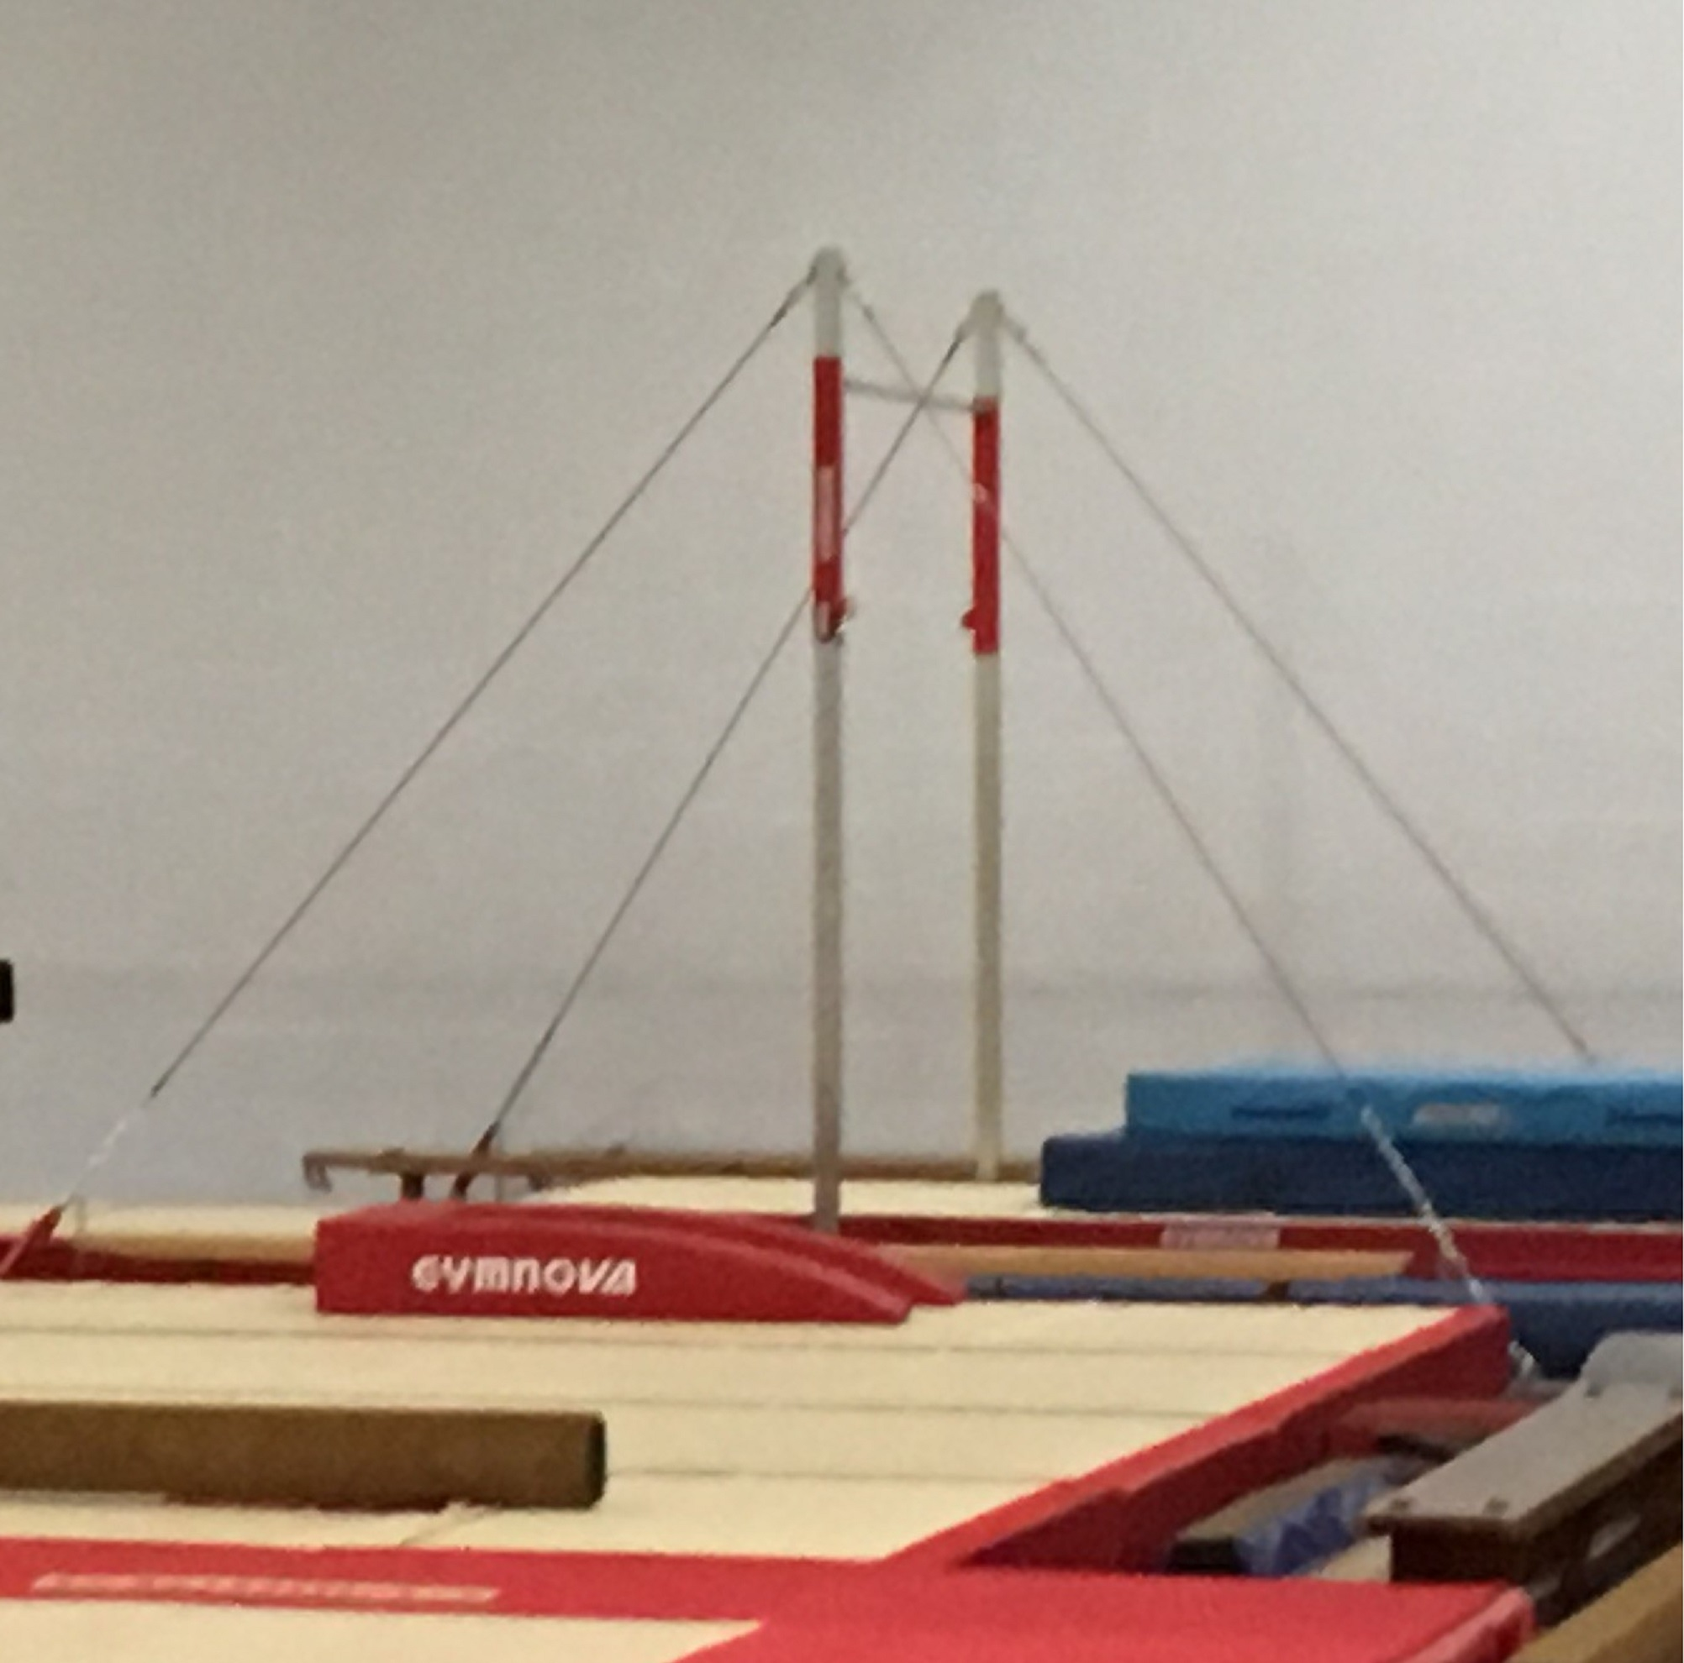
If you have any specific questions regarding the apparatus, please contact the Competition Organiser.

Deductions
You will find general deductions in the ‘Skills and Tariff Sheets’ accompanying this handbook.
There will be two judges on apparatus panel, where possible to ensure the flow and fairness of the event is maintained. The Competition Organiser will appropriately place the judges out in-line with their qualification and experience; this will also suit the categories applied to the competition.

Judge slip example
When you are nominating a judge, you may wish to show them the below judge slip. This judge slip may be like what the judges will be using on the day to work out each gymnast final score.
From this score sheet you can see how important it is for you as a coach to understand the tariff sheets correctly for judges to be able to ‘judge’ efficiently and keep the flow of the competition moving smoothly.
Example of judge’s deduction processing
Floor |  |  |  |  |  | Vault
No. |  |  | Gymnast name:
This is based on the skills performed |  |  |  | DV score (including bonus’):
 |  |  |  | C score:
 |  |  |  | Execution starting score: |  |  | 10.00
DV score + C score + Execution starting score = |  |  |  | Starting score:
What errors have they done against the requirements (max 10.0) |  |  |  | Execution deductions:
Starting score – Execution deductions = |  |  |  | Final score:

Appealing a judge’s decision
Any appeals of a judge’s Difficulty Value (DV) score decision need to be given to a Committee Member / Competition Organiser and must be submitted prior to the end of the competition.
Appeals must be submitted by the gymnast’ coach only.
This is a friendly, low-pressure, fun competition and we want to create a fair environment. We will strive to provide everyone with the best service possible.
Video evidence will not be accepted on any grounds.
Constructive feedback can be passed to the committee via the appropriate Competition Organisers within one-week post event.

Club, school, and leisure centre requirements
The following table provides information on the level of British Gymnastics membership each gymnastics environment requires to enter this event:
Environment | Club | School | Leisure Centre
Level of membership | BG Club membership | BG Club membership | BG Club membership
 | Further details can be found on the British Gymnastics website - https://www.british-gymnastics.org/clubs/club-membership/fees
Affiliation | East Midlands Region | East Midlands Region | East Midlands Region
 | Further details on how to become affiliated can be found by emailing eastmidsgfa@gmail.com

Judge, Coach, Gymnast requirements
The following table provides requirements for Judges, Coaches, and Gymnasts that are to be involved within this event:
Role/ Requirement | Judge | Coach | Gymnast
Requirements per club entry | 1 – 10 gymnasts = 1 judges  11 – 20 gymnasts = 2 judges  No judge = no entry  No show judge = £75.00 fee | A British Gymnastics Level 2 (and above) coach can take a team of gymnasts into the competition area (minimum requirement).  Level 1 coaches can support the lead coach(s).  Advanced and above competitions must have a lead coach at a minimum of BG Level 2 qualified and minimum BG Level 3 qualified for specific skills – see ‘Skills and Tariff sheets’ for further details. | For everyone’s safety, all gymnast must be suitable experienced to perform their chosen skills and routines and must have completed the skill in their own coaching environment to a point of competency.  For example, it can’t the first time they have completed the skill.
 | Only those listed on the entry form will be allowed within the competition area.
British Gymnastics ratios | N/a | 1 coach : 8 gymnasts
Qualifications | Minimum = Intro To… Judging qualification  Ideally = Floor and Vault judge, Club level judge qualification in any of the following disciplines; Men’s Artistic, Women’s Artistic, TeamGym, Tumbling  Note: Judging guides will be provided on the day. | Appropriate British Gymnastics qualifications must be held to deliver the selected skills.  See ‘Skill requirements and routines’ for further details.  All gymnasts can only perform skills that their nominated coach is suitably qualified to coach. | All gymnasts can only perform skills that their nominated coach is suitably qualified to coach.
Floor and Vault competitions:
The lead coach must be qualified one of the following: MAG, WAG, GG
Supporting coaches can be qualified in one of the following: MAG, WAG, GG, TG, TUM
Four Piece Competitions:
The lead coach must be qualified one of the following: MAG, WAG, GG
Lead coaches must be specifically qualified to the apparatus which is being performed on e.g. MAG L2 for Boys Four Piece
Supporting coaches can be qualified in one of the following: MAG, WAG, GG, TG, TUM
DBS | Yes | Yes | No
Safeguarding training | Ideally | Yes | No
Experience and abilities | Ideally some judging experience within club and/or county events.  Judging guides will be provided on the day for those who haven’t judged at this type of competition before. | Experience within delivering/supporting all skills which gymnasts are performing. | Gymnasts must be at a point of competency (within their own environment) to perform their chosen skills and routines.  For example; it can’t be the first time they have completed the skill.
Membership | BG Bronze judge membership  British Gymnastics guidance | Supervising coach = BG Gold, Joint Gold, or Life Member  Assisting coach = BG Silver (if level 1), BG Gold, Joint Gold, or Life Member  Volunteer = No membership required but must always be accompanied by a named coach  British Gymnastics guidance | BG Bronze gymnast membership  British Gymnastics guidance
Attire | Ideally = FIG standards – Navy trousers/skirt, white shirt.  Allowed = Black trousers/skirt, white shirt. | Suitably recognisable by all.  Appropriate to spot/support gymnasts during practice and performance.  Following BG Education guidance. | Clothing = Tight fitting shorts, T-shirt, Leotard, Leggings, Leotards preferred if not shorts, matching gymnastic shorts may be worn but not cycling shorts.  Hair = Neat and tidy, tied back from the face.  Feet = Bare or gym shoes  Judges must be able to see clearly the angles of the body for accurate scoring.  This is also a safety issue if any supporting is required by a coach.  Staying warm = Additional suitable clothing on top during rest periods
Payment arrangements | Judges linked/representing a club participating within the competition = Expenses to be claimed from the linked club they are representing.  Judges not linked/representing a club participating within the competition = Travel expenses can be claimed from the Competition Organiser.  Judges must initially be registered as a ‘Supplier’ with British Gymnastics – Form can be found on the BG website section – Clubs > Volunteers > Document downloads  Judges can then claim by completing and returning the Volunteer Expenses claim form to the Competition Organiser – Found on the BG website section – Clubs > Volunteers > Document downloads  10 working days to claim. | It’s not the host clubs’ responsibility to financially support the coaches to attend this event. | N/a
Transport arrangements | Judges are required to organise their own method of transport to and from the competition at the appropriate times. | Clubs and coaches are responsible for organising appropriate transport to and from the event.  British Gymnastics guidance
Jewellery and body adornments | Please set a precedent for coaches, gymnasts and spectators of professionalism. | British Gymnastics has a strict no jewellery policy during training or performance. Please ensure all piercings and body adornments are removed prior to the competition.  British Gymnastics guidelines
Additional requirements | If any anyone has any additional requirements to support their time during the event e.g., they have a disability that requires additional support or consideration by the Competition Organiser. Please add this into your competition entry.
If requirements are not upheld, then the Competition Organiser has the right to withdraw your (and possibly your clubs’) right to step into the competition area.
If your club is unable to find a judge (or doesn’t have one) please don’t worry. Contact the British Gymnastics Competition Coordinator to discuss your options and how you can gain/train a judge. See Key contact section.

Volunteers
Volunteers are to be listed on the entry form to ensure that anyone providing support is allowed within the competitive area, including waiting and warm up areas.
Volunteers must be DBS checked and must always be supervised by a qualified coach.
Volunteers are not coaches’ and therefore not allowed to ‘coach’.

Facilities on-site

Spectator area and disabled access
Both New College and Erewash Valley sites have disability access. If you require any specific access, please contact the Competition Organiser.
Both New College and Erewash Valley sites have plenty of seating for our events. Seating is made from plastic materials, if you require a softer seat please bring suitable padding.

Food and drink
Both Amber valley has a café.
Erewash Valley will have cold refreshment catering facilities.

Toilet and changing facilities
Both Amber valley and Erewash Valley have baby changing facilities, changing facilities and plenty of toilets.

On-site entertainment
Neither Amber valley nor Erewash Valley have any on-site entertainment facilities apart from the sport of gymnastics. If you have small children, you may wish to bring something to keep them entertained.
We can’t take responsibility for any losses or damages to personal property.

Car parking
Both Amber valley and Erewash Valley sites have plenty of free parking on-site.

First aid and welfare
The following provision will be available during this event:
- Trained First aider
- Trained Welfare Officer
These roles will be highlighted during the coaches and judges’ briefings.
It would be most helpful if the supporting coach from each club is First aid trained (or more) particularly to support their own gymnasts, however this isn’t essential.

Regulations

Standardisation
Unless stated these regulations have been created to help standardise competitions within recreational events.

Etiquette
While competitions can become competitive, please ensure you support every gymnast, coach and parent/guardian involved. Everyone has been involved at some point and every competition/event is a celebration of those efforts.
It is important that the access to the ‘Officials area’ (judges, scoring, music etc.) is restricted to authorised personnel only.
The Competition Organiser has the right to withdraw any entry/entries where appropriate etiquette and professionalism isn’t upheld before, during and after the event. This therefore could affect future attendance at events and become a welfare issue.

Photography
It is your responsibility as the coach in charge of your entered team/club to be aware, and have records, of anyone that can/can’t have their photo/video taken for media purposes. If you have anyone that can’t, please ensure the Competition Organiser is aware prior to the date of the event so they can inform the appropriate persons so that any photography/video of them is avoided. This can be done via emailing the Competition Organiser upon entry.
The following information is taken from the British Gymnastics policies and must be passed onto those who will be representing your club at this event, including spectators. At various points throughout the day the hosting club will also announce this information:
In the interests of child protection, photographs and video may only be taken during
today’s event in accordance with conditions set by British Gymnastics. Summaries of
these conditions are on display and you can see a copy of the full conditions at the reception desk. Photos may only be taken for personal use. Unless specifically
accredited to do so, you may not take photos for sale, other commercial use or for
publication in printed or electronic form, such as on websites.
Some photos may be published by Clubs, but this may only be done in accordance with the British Gymnastics Child Protection Policy.
DE Photos will be on-site during many Regional GfA events to help capture each gymnasts’ special moments.
If you have any concerns about the identity or actions of any photographer or if you believe that any unsuitable photos are being taken, you should report your concerns to Welfare Officer/Competition Organiser. In the interests of child protection please do let us know of anything that may be damaging to the welfare of a child.
The use of flash or supplementary lighting is not permitted while gymnasts are warming
up or competing. Please make sure that the flash is turned off on any device being used as your camera.
The use of live streaming is not permitted during any part of this event.
When ‘posting’ images on personal social media please ensure the following to reduce the risk of publication of the image (this isn’t the full list but key from the policy):
- Personal details are kept to a minimum – Use of their first name only etc.
- Suitable, sensible, and appropriate image taking/selection – Avoid such skills as splits and sensitive areas on the body
- Blur anyone else out of the image – Use technology to blur others out the image (if you can’t, don’t take/post the image)
If the Competition Organiser/Welfare Officer suspects inappropriate photography or filming, the Officer/Organiser should exercise their powers under the conditions to request the person to leave the venue and to surrender any film and/or delete any images relating to the event.
For full details please see the British Gymnastics policies:
- British Gymnastics Photography Regulation – https://www.british-gymnastics.org/documents/footer-menu-items/british-gymnastics/3276-photography-policy/file
- British Gymnastics Safeguarding Children: Safe environment Policy – https://www.british-gymnastics.org/documents/departments/membership/ethics-and-welfare/safeguarding-and-protecting-children/7769-safeguarding-children-safe-environment-06-2016/file

Complaints and grievances
If you have a complaint or grievance regarding any happenings about or at this event, please ensure you send in your details to the Competition Organisers’ email within five working days of the event date.
If there is a problem on the day of the competition, the competition will go ahead as programmed, and the problem will be addressed later after the competition with the parties concerned.
The parties with the grievance will meet the committee to see if an amicable decision can be made for the good of all parties and Gymnastics for All Committee.
It will then go to a committee vote.
If no agreement can be made the Chairman will make the final and binding decision.

Health and safety
Overview
The health, safety and welfare of all participants (gymnasts, coaches and officials) is the primary consideration. All British Gymnastics policies and procedures will be rigorously applied with regards to health, welfare and safeguarding and protecting children.
The intention of the event is to create a friendly and no-stress/low-pressure environment for all those involved, while allowing gymnasts the opportunity to challenge themselves to do their best. Ensuring the safety of the gymnasts, no matter their age, is a priority in the event set up, programme design, and risk assessment, using the guidance set out by British Gymnastics in its Safe Coaching Practice document – https://www.british-gymnastics.org/documents/clubs-schools-and-leisure-centres/8851-h-s-guidance-safe-coaching-1/file
Risk assessments
Risk assessments have been carried out for this event but if you feel there is something/one that may require additional assessment please contact the Competition Organiser ASAP with specific details.
While risk assessments for the event have been completed, your club is responsible for specific risk assessments related to your club e.g. travelling to and from the event etc.
Welfare
As part of your risk assessments and preparation for the event, please consider the welfare of individual gymnasts, including such items:
- Clothing not being revealing/embarrassing for males, females, and transgender gymnasts/coaches/judges.
- Age of gymnasts when changing, socialising etc.
The British Gymnastics Health, Safety and Welfare policy has guidance on such areas and there are a few videos/courses which may help you also:
Resource Title | Type | Link
British Gymnastics Health, Safety and Welfare policy link | Policy | Link
Risk assessment training for clubs | British Gymnastics eLearning course | Link
GDPR Date Security | British Gymnastics eLearning course | Link
GDPR Implementation | British Gymnastics eLearning course | Link

Allergies
As part of the safety for everyone, please ensure you pass on the message to all your coaches, gymnasts, judges, and parents/spectators that any food being brought to the event should be nut free and keep in mind any other potential allergies that could be affected by food being brought.

Emergencies
As part of event, everyone attending must adhere to the emergency procedures and follow the professional guidance of the Competition Organiser and members of staff from the venue. Below is a brief guide of the venue emergency procedures.
At Erewash Valley and Amber valley
Coaches must remain in charge of their gymnasts, leading them out the nearest fire exit and to the appropriate meeting point (see signage in venue).
Spectators will leave via the nearest emergency exits in an event of an emergency.
Judges are to support the coaches in leaving the venue with their gymnasts but to report to the head judge once at the appropriate meeting point.
At New College (specifically)
In the event of the emergency alarms sounding please evacuate via one of the following routes:
- Spectators – Use the emergency exits at either side of the seating
- Gymnasts, coaching, and managers – Use either of the three emergency exits in the main hall
- Café – Follow the emergency exit signage to the South Entrance car park emergency exit route
Meeting point is in the South Entrance car park.
At Erewash Valley (specifically)
In the event of the emergency alarms sounding please evacuate via one of the following routes:
- These will be highlighted on the day during a safety briefing
The meeting point is within the car park (side of building)
Coaches are to ensure all their gymnasts are kept together until registered and then handed back to their responsible adult.

Terms and conditions
By entering this event your club is agreeing to the rules, regulations, and standards within this handbook.
Failure to comply may see your club being excluded from the event without refund.

